

Travlr

CS 465 Project Software Design Document
Version 1.0

Table of Contents

CS 465 Project Software Design Document 1
Table of Contents 2
Document Revision History 2
Instructions 2
Executive Summary 3
Design Constraints 3
System Architecture View 3
Component Diagram 3
Sequence Diagram 4
Class Diagram 4
API Endpoints 4
The User Interface 4

Document Revision History

Version | Date | Author | Comments
1.0 | 11/15/2025 | Seth Richey | Added First 3

Instructions

Fill in all bracketed information on page one (the cover page), in the Document Revision History table, and below each header. Under each header, remove the bracketed prompt and write your own paragraph response covering the indicated information.

Executive Summary
For this project, the Travlr Getaways web application will be built using the MEAN stack: MongoDB, Express, Angular, and Node.js. This tech stack works well for a full stack project because everything uses JavaScript, which keeps the development process consistent and easier to maintain. The overall goal is to deliver a system that includes both the public-facing website for customers and an administrative single-page application (SPA) that staff can use to manage travel content.
The customer-facing portion of the site will focus on helping users browse trips and view important travel details like prices, descriptions, and destinations. These pages will be delivered by the Express server and will pull all of their information from the MongoDB database through the same API used by the admin tools. This keeps all customer-visible content up to date.
The administrative SPA, built in Angular, gives Travlr staff a secure and efficient way to update trips. Once logged in, admins can edit, add, or delete travel listings. The SPA communicates with the backend through REST API calls and updates views without refreshing the entire page. This creates a smoother experience and keeps admin tasks quick and responsive. Separating the customer site from the admin SPA also improves security and keeps responsibilities clearly divided.

Design Constraints

Several constraints influence how the Travlr Getaways application is designed and built. First, the course requires the use of the MEAN stack. This standardizes the project but also limits technology choices—we can’t use SQL databases or alternative frontend frameworks. Because of this, the design has to work within the strengths and limitations of MongoDB and Angular.
Security is another major constraint. The admin SPA must be restricted so that only authorized users can make changes. This requires secure authentication, protected API routes, and careful handling of sensitive data. These rules shape how the backend endpoints are structured.
Performance and scalability also matter. Since multiple users might access the site at the same time, the backend needs to handle requests efficiently. This affects how MongoDB queries are written and how much data we return at once.
Usability is another important limitation. The site needs to work well on different devices, and both customers and admins should be able to find what they need without confusion. This impacts layout choices, page structure, and the organization of UI elements.
Finally, the overall project scope and timeline limit how many features can be included. The priority is to support browsing trips for customers and basic CRUD functionality for admins, which means more advanced features must be left out for now.

System Architecture View

The Travlr Getaways application uses a layered architecture similar to most MEAN stack projects. At the top layer, web browsers act as clients for both the customer website and the admin SPA. Customers request pages from the Express server, while admin users load the Angular SPA, which then communicates with the backend through API calls.
The Node.js and Express server sits between the client and the database. It handles routing, serves static files, and exposes the REST API endpoints for retrieving and updating trip information. This middleware layer also manages authentication for admin users.
Behind the server is the data access layer, which interacts with MongoDB. This layer handles all operations related to creating, reading, updating, and deleting documents in collections such as trips and admin accounts.
In short, the architecture consists of:
- Client browsers that display the customer site or admin SPA
- Angular SPA for admin tools and CRUD interactions
- Express/Node.js server that handles business logic, routing, and API endpoints
- Data access/model layer that manages MongoDB operations
- MongoDB database that stores all persistent site data
All components communicate through well-defined routes and APIs, keeping the system organized, consistent, and maintainable.

Component Diagram

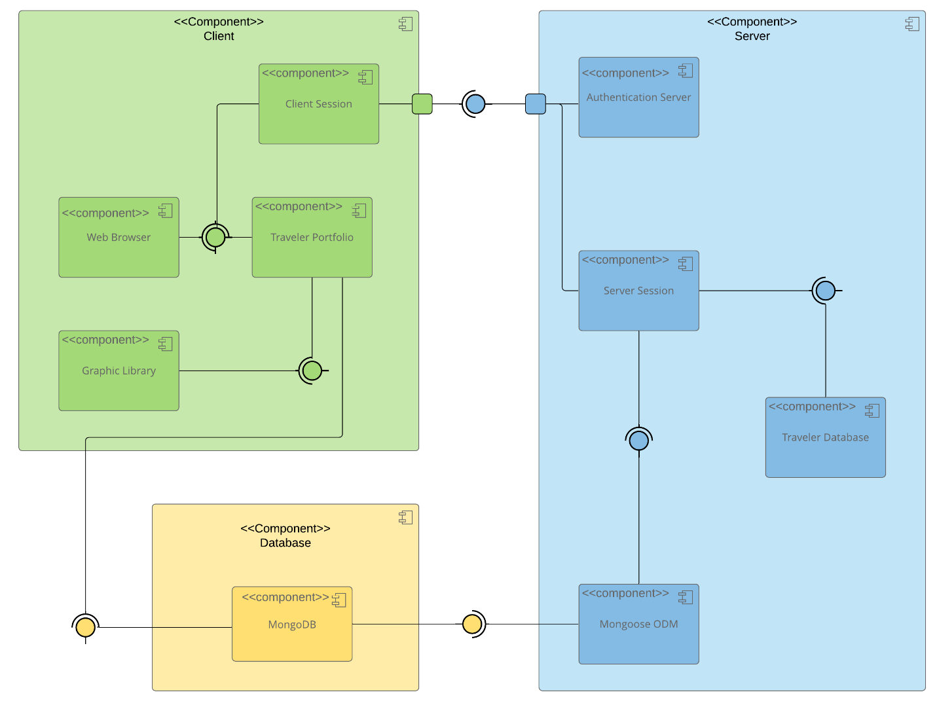

A text version of the component diagram is available: CS 465 Full Stack Component Diagram Text Version.

Sequence Diagram
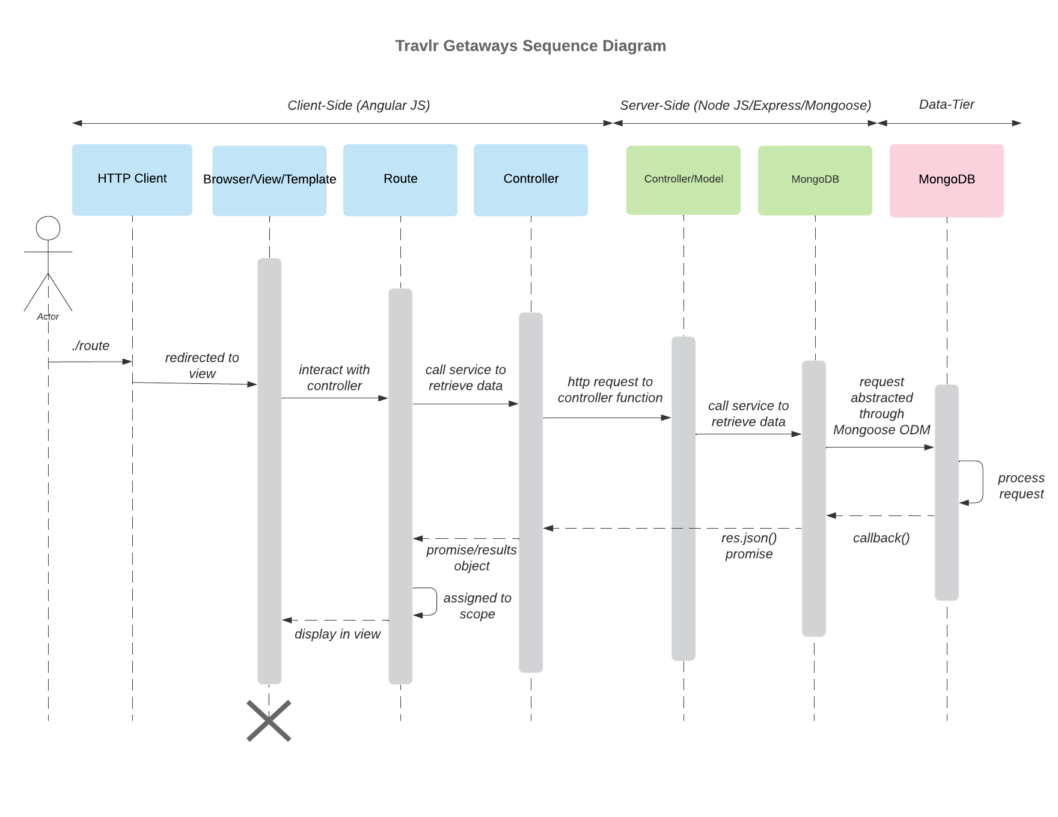

The sequence diagram illustrates how the Travlr Getaways web application processes a user request from the browser through the server and into the database. When the user navigates to a page such as /travel, the browser sends an HTTP request to the Express route that matches the URL. The route forwards the request to the appropriate controller, which contains the application logic for handling trip data. The controller then interacts with the Mongoose model to retrieve information from MongoDB. After the model queries the database and receives the results, the controller sends the data back to the Handlebars view. Finally, the browser renders the completed HTML page for the user. This diagram highlights how the browser, route, controller, model, and MongoDB work together to serve both page views and API responses.

Class Diagram
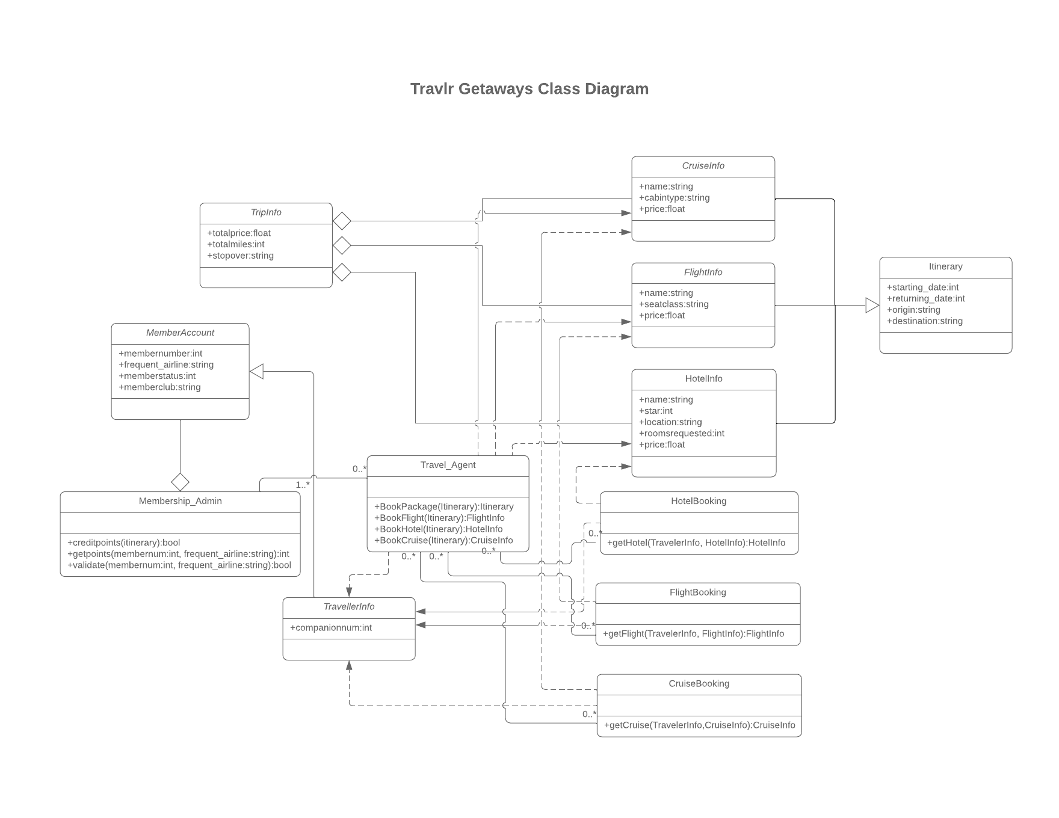
The class diagram represents the major data structures that support the Travlr Getaways application. At the center of the design is the TripInfo class, which stores core information about each travel package. Supporting classes such as FlightInfo, HotelInfo, and CruiseInfo describe the different components that can be part of a trip. The booking classes—FlightBooking, HotelBooking, and CruiseBooking—connect a traveler to reservations for each type of travel service. User-related data is represented through the TravellerInfo, MemberAccount, and Membership_Admin classes, which model customer profiles, account details, and administrative functions. The Travel_Agent class connects these pieces by handling the actions involved in booking or managing a trip. Together, these classes show how the application organizes trip data, manages travelers, and supports bookings.

API Endpoints

<Exposing RESTful endpoints is a design approach to enable an application to participate in a larger ecosystem. Document each endpoint in the table below, including the HTTP method, purpose, URL, and notes.>

Method | Purpose | URL | Notes
GET | Returns all trips in JSON format | /api/trips | Used by API clients to retrieve all trip data
GET | Returns a specific trip by ID | /api/trips/:tripId | Receives an ID parameter and sends matching trip data
GET | Renders the main travel page | /travel | Uses Handlebars to display a list of trips
GET | Loads the homepage | / | Entry point for the customer-facing website

The User Interface
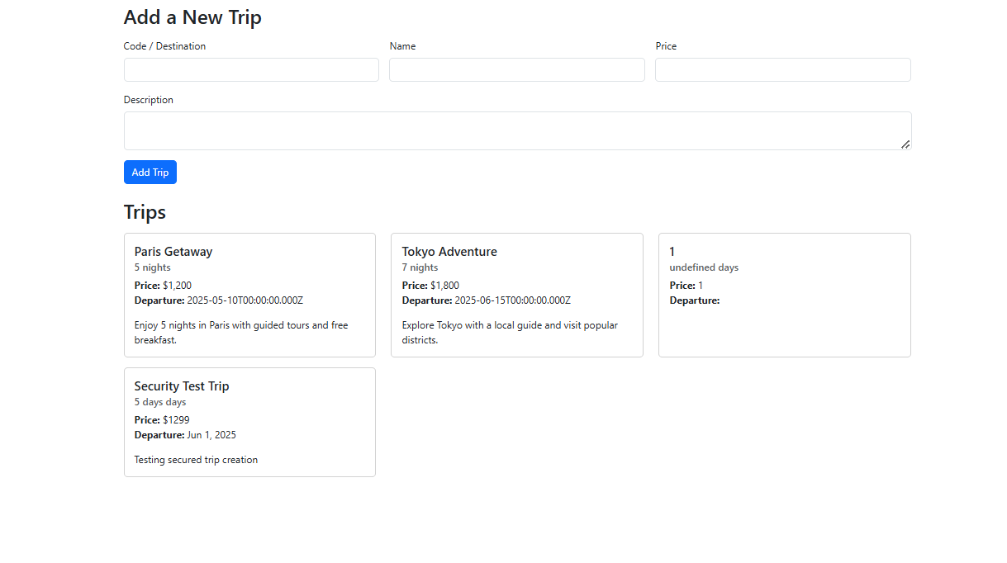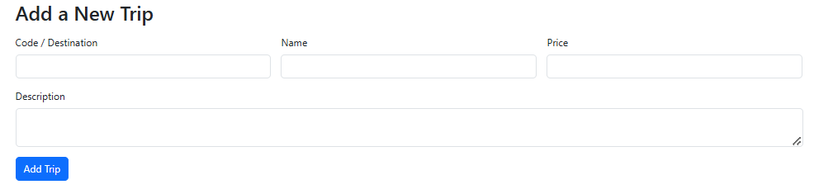Admin SPA form used to create and modify travel packages.
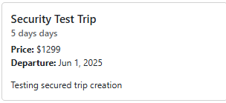
Updated trip data displayed after submission through the SPA.

The User Interface

The administrative user interface for Travlr Getaways is implemented as a Single Page Application (SPA) using Angular. The Angular project is organized into components and services that handle user interaction and communicate with the backend REST API. This structure differs from the Express customer-facing application, which follows an MVC pattern and uses server-side Handlebars templates to render pages.

The Angular SPA allows administrators to add new travel packages and view existing trips without requiring full page reloads. Trip data is retrieved from the API using HTTP GET requests, and new trips are created using HTTP POST requests. Once a trip is added, the updated data is immediately displayed in the interface, providing a responsive and efficient administrative experience.

Testing focused on verifying that the SPA successfully communicates with the API. GET requests were used to retrieve trip data from the MongoDB database, and POST requests were used to create new travel packages. Additional testing with Postman confirmed that administrative endpoints are secured and require authentication, ensuring that only authorized requests can modify trip data.

